AI/ML Hackathon - Ministry of Panchayati Raj (Geospatial Intelligence Challenge)
Powered by: Geo-Intel Lab, IITTNiF

Accurate extraction of infrastructure features from high-resolution satellite imagery remains difficult due to reliance on manual interpretation and lack of automated solutions.

AI-Driven Multi-Class Geospatial Segmentation for Rural Infrastructure Mapping

SRM Institute of Science and Technology, Kattankulathur

Supported by
Geospatial Intelligence and Applications Laboratory,
IIT Tirupati Navavishkar I-Hub Foundation

1. Title of the Idea

AI-Driven Multi-Class Geospatial Segmentation for Rural Infrastructure Mapping

2. Team/Individual Name & Affiliation

Jashwanth B - B.Tech Computer Science and Engineering, SRMIST
jb4335@srmist.edu.in
Tejeshwar Senthilkumar - B.Tech Computer Science and Engineering, SRMIST
ts2682@srmist.edu.in
Krishita Satish Kumar - B.Tech Computer Science and Engineering, SRMIST
ks8116@srmist.edu.in
Anugrah Upadhyay - B.Tech Computer Science and Engineering, SRMIST
au3887@srmist.edu.in
Sayani Bharath - B.Tech Computer Science and Engineering, SRMIST
bs3848@srmist.edu.in

3. Problem Statement Addressed

Rural and semi-urban regions lack accurate, structured, and up-to-date geospatial data for critical infrastructure such as roads, buildings, water bodies, and utilities. Existing mapping approaches rely heavily on manual surveys or low-resolution satellite interpretations, which are time-consuming, expensive, and difficult to scale across large geographic regions.

This limitation affects planning, resource allocation, disaster response, and infrastructure development at the Panchayat level. Additionally, high-resolution satellite imagery is complex to interpret due to varying terrain, overlapping features, and class imbalance, where small but important objects like utilities are underrepresented.

The challenge is to develop a scalable, automated system capable of extracting high-resolution, multi-class geospatial information from satellite imagery with high accuracy, enabling data-driven rural governance and infrastructure planning.

4. Proposed Solution
This project proposes an AI-powered geospatial intelligence system that performs multi-class semantic segmentation on high-resolution orthophoto imagery to automatically identify key rural infrastructure components.

The pipeline begins with geospatial preprocessing, including CRS standardization (EPSG:32644), rasterization of shapefiles, and tiling of imagery into 1024×1024 patches to preserve spatial detail. Individual class masks (roads, roofs, water bodies, utilities) are combined into a unified multi-class segmentation map using priority-based encoding.

The segmentation model is based on DeepLabV3+, leveraging lightweight encoders such as MobileNetV2 for efficient training and deployment, and advanced encoders like MIT-B4 for high-accuracy performance. A hybrid loss function combining Dice Loss and CrossEntropy/Focal Loss ensures robust learning while addressing class imbalance and improving boundary precision.

The system includes a complete training and inference pipeline. During inference, large images are tiled, processed, and stitched back together to generate full-resolution segmentation maps. Post-processing techniques improve output quality, and the pipeline supports optional object-level classification for deeper semantic understanding.

The solution is designed to be scalable, efficient, and adaptable for deployment across multiple villages, enabling real-world geospatial intelligence applications.
5. Uniqueness and Innovation

The proposed system stands out by combining high-resolution geospatial processing with advanced deep learning techniques to create a scalable and accurate infrastructure mapping solution.

Unlike traditional approaches that rely on manual digitization or coarse-resolution analysis, this system operates on 1024×1024 tiles, preserving fine spatial details such as narrow roads and small utilities. The use of a hybrid loss function (Dice + CrossEntropy/Focal) effectively addresses class imbalance, ensuring that both large regions and small objects are accurately segmented.

A key innovation is the structured end-to-end pipeline that integrates preprocessing, segmentation, and optional post-segmentation classification. The system is designed to evolve into an advanced architecture (LA-TASCNET), incorporating location-aware features and task-adaptive learning for improved spatial reasoning.

Additionally, efficient training strategies such as mixed precision training and gradient accumulation allow high-performance models to run on limited hardware. The ability to balance accuracy and efficiency through lightweight and high-capacity models makes this solution highly practical and deployable.

6. Technology Stack / Methodology

The system integrates geospatial data processing tools with deep learning frameworks to build an end-to-end segmentation pipeline.

Geospatial Processing:
QGIS and GDAL are used for CRS standardization (EPSG:32644), raster alignment, and shapefile processing. Vector layers for roads, buildings, water bodies, and utilities are rasterized into aligned masks and combined into multi-class labels.

Data Processing:
OpenCV and NumPy are used for image loading, preprocessing, and normalization. Albumentations is used for applying spatially consistent augmentations such as flipping, rotation, and affine transformations.

Deep Learning:
The model is implemented in PyTorch using the segmentation_models_pytorch library. DeepLabV3+ serves as the core architecture, with encoders such as MobileNetV2 (lightweight) and MIT-B4 (high accuracy).

Optimization:
Training uses mixed precision (AMP) and gradient accumulation to optimize GPU usage. A hybrid loss function (Dice + CrossEntropy/Focal) ensures balanced learning across classes.

This methodology ensures scalability, accuracy, and efficient training on high-resolution geospatial data.

7. Expected Impact (Environmental, Social, Economic, etc.)

The proposed system enables automated extraction of rural infrastructure data from satellite imagery, significantly reducing dependence on manual surveys.

Environmental Impact:
Supports monitoring of water bodies and natural resources.

Social Impact:
Improves rural planning by identifying roads, housing clusters, and utilities.

Economic Impact:
Reduces cost and time associated with traditional mapping methods.

Governance Impact:
Enables Panchayati Raj institutions to make data-driven decisions for infrastructure development, disaster management, and resource allocation.

Overall, the system transforms raw satellite imagery into actionable geospatial intelligence, improving efficiency and planning at scale.

8. Implementation Plan / Roadmap

The project has been actively developed over the past one month and has progressed through key implementation stages.

Phase 1 (Completed): Data Preparation
Orthophoto imagery and shapefiles were collected and standardized to EPSG:32644. Vector data was rasterized into aligned masks, and the dataset was tiled into 1024×1024 patches. Data cleaning was performed to remove low-quality and empty tiles.

Phase 2 (Completed): Dataset Structuring
Multi-class masks were generated using priority-based encoding. The dataset was organized into training and validation sets with proper distribution across villages.

Phase 3 (Ongoing): Model Development
A MobileNet-based DeepLabV3+ model is currently being trained and evaluated. Metrics such as mIoU and class-wise IoU are used to analyze performance and identify weak classes.

Phase 4 (Planned): Model Optimization
A high-performance MIT-B4 model will be trained, along with techniques such as boundary refinement and augmentation tuning to achieve higher accuracy.

Phase 5 (Planned): Deployment Pipeline
An inference pipeline will be developed for tiling, prediction, stitching, and generating GIS-compatible outputs.

9. Required Resources

Hardware:
GPU-enabled systems (RTX 4050/4060 or higher) and 16–32 GB RAM.

Software:
Python, PyTorch, segmentation_models_pytorch, OpenCV, Albumentations, QGIS, and GDAL.

Data:
High-resolution orthophoto imagery and annotated shapefiles.

Expertise:
Knowledge in deep learning, computer vision, and geospatial data processing.

These resources are widely available, making the solution practical and implementable.

10. Scalability and Sustainability

The system is highly scalable and can be applied across multiple regions using standardized preprocessing and tiling pipelines.

The tile-based approach allows efficient handling of large geographic areas, while the modular architecture enables easy addition of new classes or datasets. The model can be retrained periodically with updated satellite imagery, ensuring long-term relevance.

Sustainability is achieved by reducing reliance on manual surveys and enabling automated, repeatable geospatial analysis. Lightweight models can be deployed on edge devices, making the solution practical for real-world applications in rural development and governance.

11. Stakeholders and Collaborations (if any)

The primary stakeholders are government and planning bodies that require accurate geospatial intelligence for rural infrastructure management.

Key stakeholders include the Ministry of Panchayati Raj and local Panchayat administrations, which can use the system for infrastructure planning, resource allocation, and rural development.

The Geo-Intel Lab at IIT Tirupati serves as a technical and evaluation stakeholder, defining the problem scope and assessing solutions.

Potential collaborators include GIS professionals and satellite data providers who can assist in data integration and deployment within GIS platforms.

The system ultimately benefits rural communities by enabling better planning of roads, housing, water resources, and utilities through data-driven decision-making.

12. Current Stage of Development

Stage: Prototype / MVP

The project has reached a functional prototype stage with a complete data pipeline, including preprocessing, tiling, mask generation, and model training. A baseline MobileNet model is currently being evaluated, and a high-performance MIT-B4 model is planned. Ongoing work focuses on improving accuracy, handling class imbalance, and preparing for deployment.

13. Supporting Materials (Optional)
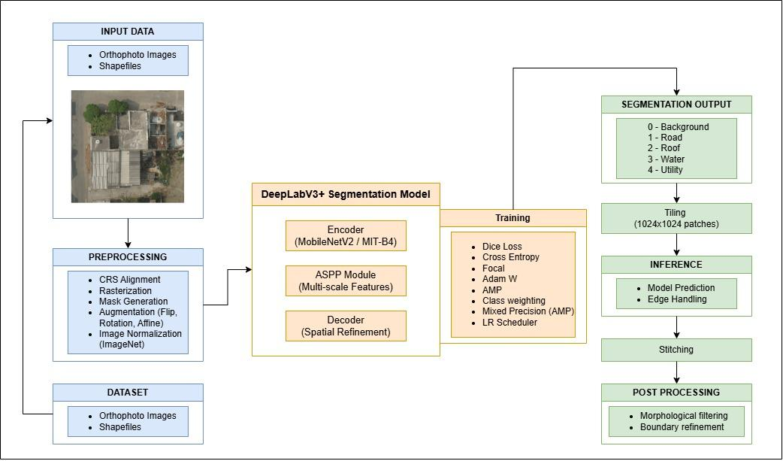
Architecture Diagram:

Presentation For Pitch Deck:
https://www.canva.com/design/DAHFcH4tuQI/9C6ICkHBR5kC-iG66HmKpA/edit?ui=e30&referrer=https%3A%2F%2Fwww.canva.com%2F

